R-TEAM Robotics Club

2018 Target Plate System Incremental Improvement Plan

June23, 2017 John Harkey

**Background**

The Mechwarfare legacy target system has been incrementally changed on an almost yearly basis in an effort to mitigate deficiencies and improve performance. Some of the past changes include:

1. Multiple spins of the transponder board
2. Addition of a quad LED hit indicator
3. Changes in the transponder software
4. Changes in the laptop scoring software
5. Changes in the target plates
6. Changes in how the target plates have been provided

By 2017 Robogames the target system incremental changes had resulted in the best performing target system in the history of Mechwarfare. The 2017 system (when powered) required no human intervention to count hits. Also the hits were considered fair with no uneven scoring bias. Nearby radio interference did not effect the operation of the target system so all hits were registered. No false hits were registered. These results were due in part to the following changes to the system:

1. All target plates were the same, pre-certified and loaned out at Robogames to competitors. Plates were checked prior to a match and after a match. All competitors appeared to prefer this method as it relieved them of the burden of supplying target plates and promoted a sense of fairness among competitors.
2. The transponder software on the robot kept track of the robots score and repeatedly reported the score to the laptop software. This key change eliminated the radio interference consequences.
3. Each target plate had 3 LEDs that lit up quite brightly from a bb hit which provided feedback to the shooter that a hit registered. It also provided a visual indicator to the audience. This also confirmed the fairness of the hits.
4. Software controlled target rule enforcement; 15 hit limit on each plate, Quad LEDs latch on at 0HP

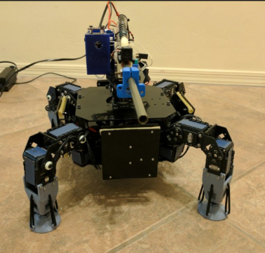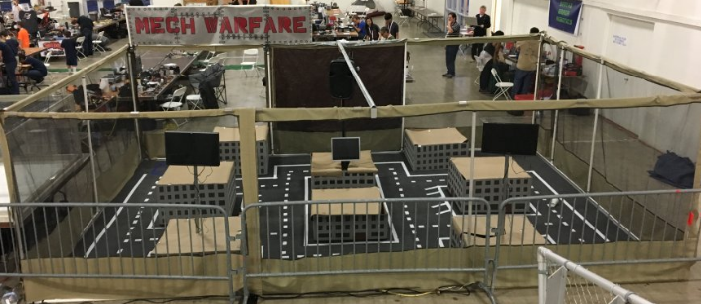

**Deficiencies**

The 2017 Robogames target system is good enough to continue to use “as is” for 2018. Having said that, several deficiencies surfaced that were manageable but not wanted. This means changing the target system yet again…argh!

Deficiencies:

1. Multiple delrin target plates cracked, split, shattered with high velocity bb hits (> 150fps).
2. Multiple piezo sensor circuit cards were damaged from the bb hit shock traveling thru the delrin plate
3. There were 3 matches were the robot on/off switch was hit by a bb and robot de-powered. Since the target plate system obtains its power from the robot the target system ceased functioning.
4. One of the robots appeared to have intermittent target system power which rendered it intermittent
5. No explicit match rules to address robots loosing power which resulted in the judges having to make decisions that may have been perceived as not being consistent.

**Changes**

An incremental change approach is preferred as it consumes time and resources to make these changes to a system that at this time is “good enough”. The incremental changes would be compatible with the existing system so at all times there would be a working system that was continually improving. It is a goal to not have to revisit each individual change at a later date because each change would be consistent with the final vision of the working system.

The following run rules will be used for making the incremental changes:

1. The change will fix a problem, increase the performance or provide flexibilty of the system
2. The change will be compatible with the existing state of the system
3. The change is consistent with the final vision of the system
4. The change will not have to be undone at a later date to be consistent with the final vision
5. All changes will be done over a 2 year period or less

The following prioritized incremental changes are planned:

1. Replace the delrin front plate with a material that will withstand the bb hits up to a velocity of 200 fps
2. Move the piezo circuit card away from the front plate mounting to the back frame
3. Add an independent power source to the target system on the robot so if the robot looses power the target system will still work
4. Write explicit rules to address a de-powered robot
5. Write a maximum projectile velocity rule that will be verified during qualification
6. Redesign the piezo sensor circuit card using a small micro-controller to allow for future flexibility and minimize the part count and reduce the 4 layer pwb to a 2 layer pwb
7. Redesign the transponder card to be smaller and contain one piezo sensor circuit to facilitate mounting it to the rear target plate frame. The battery will also be mounted to the rear plate frame. This will allow us to loan out the entire target system instead of just the target plates. We could provide the wire harness or the competitor can provide those in his robot.
8. Eliminate the top quad LED indicator board for the following reasons:
   1. Target system is reliable and requires no human intervention
   2. Target plates light up to indicate hits are occurring
   3. Target plates can all light up one after another in a circular fashion to indicate 0HP have been reached
   4. The quad LED indicator board is extra hardware that consumes weight, volume and wire routing.

**Target Plate Size Discussion**

An unrelated issue to target plate system deficiencies is target plate size changes. This recently came up for discussion after Robogames. The plan is open at this point in this regard but presented are the current rational for and against this change. The reason the legacy plate is 3.5”x 3.5” is because that is the size dictated by having 4 FSR sensors stuck to the front. We no longer have that constraint. Several people have reasoned that a smaller plate (3”x3” or 2.75”x2.75”) may be more appropriate now.

Reasons for changing the plate size:

1. Guns can hit accurately now so making the plate smaller is OK
2. The plates indicate a hit by lighting up so the shooter has feedback
3. A narrower plate will allow a robot to be narrower which perhaps can make it faster with longer limb lengths while not giving up maneuverability
4. Many of our robots minimum sizes are constrained by the target plate width

Reasons for keeping the plate legacy size:

1. It is the legacy plate size and it may be awkward rationalizing why the size has shrunk to an arbitrary smaller size to the community of practice.
2. For 2017 we introduced the lightweight mech of under 3 pounds with legacy half plate sizes. This implies that if you want a smaller plate size you need to build a light weight mech. The half size plate & lower HP for the lightweight mech class is consistent with less pretend armor
3. The legacy size constraint is good because it puts a lower bound on the normal weight class size
4. If we introduce a heavyweight class we may want to naturally constrain the minimum size by larger target plates and more HP which is consistent with more pretend armor